**City of White House**

**Municipal Board of Zoning Appeals**

**Tuesday, May 17, 2022**

**7:00 p.m.**

**STAFF RECOMMENDATION REPORT**

**Item #1 Joseph and Jenna Mayhew:** Requests a special exception to allow an accessory residential family dwelling unit. Property is zoned R-20, Low Density Residential. Property is referenced as Sumner County Tax Map 077J, Group D, Parcel 012.00 and is located at 100 Edwards Court.

**Item #2 April Carnal:** Requests a special exception to allow an accessory residential family dwelling unit. Property is zoned R-20, Low Density Residential. Property is referenced as Sumner County Tax Map 077J, Group C, 009.00 and is located at 209 Hobbs Drive.

**STAFF NOTES: I combined my staff comments to reflect both of the agenda items, because both are requests for accessory residential family dwelling units.**

The applicants for Edwards Court and Hobbs Drive submitted information detailing the location of the proposed building addition and the intention for the accessory dwelling unit to be used for a family member. Both properties are zoned R-20, Low Density Residential which permits an accessory family dwelling unit through the Board of Zoning Appeals special exception review process. The proposed accessory dwelling unit on Hobbs is proposed to be constructed on the back of the existing house and will share the existing address, utility meter, and driveway. See building and property area information listed attached. This is a rough sketch. The applicant will be required to adhere to all building codes and zoning regulations. The proposed accessory dwelling unit on Edwards Court will be a garage enclosure, adding a kitchen and bathroom, thereby creating an accessory dwelling unit by definition.

**Item #1 100 Edwards Court**

Property Area- 22,277 sq. ft.

Existing House- 2,400 sq. ft.

Proposed Addition: 400 living space (garage enclosure)

Permitted Total Building Lot Coverage in R-20 Zoning District -thirty-five (35%) percent

**Item #2 209 Hobbs Dr**

Property Area- 21,019 sq. ft.

Existing House- 1,050 sq. ft.

Proposed Addition: 375 (estimated) living space

Permitted Total Building Lot Coverage in R-20 Zoning District -thirty-five (35%) percent

The Board will need to review the proposed request in relation to the Zoning Ordinance Sections 9.070 (F) and 4.190 to determine if the request meets the requirements. The basis for the motion to approve, defer, or deny the request including any approval stipulations/conditions per the provisions of 9.070 (B)(Restrictions) will need to be included in the motion.

Staff has a standard agreement format document that can be used to define the Board’s approval (if approved) including any stipulations and for the applicant to confirm that the addition is to be used for family members.

**Staff Findings of Fact:** Both of these request meets the provisions of the special exception review criteria subject to applicant providing a recorded statement prior to the building permit being issued.

**ZONING ORDINANCE REFERENCED SECTIONS:**

**2.020 Definitions**

Accessory Use. A use customarily incidental, appropriate, and subordinate to the principal use of land or buildings and located upon the same lot therewith.

Dwelling. A building or part thereof used as a habitation under one of the following categories:

a. Single detached dwelling means a building and accessories thereto principally used, designed, or adopted for use by a single family.

Family. One of the following:

a. An individual, or two (2) or more persons occupying a dwelling unit and living as a single independent, nonprofit housekeeping unit, together with incidental domestic servants and temporary non-paying guests.

b. A group of not more than six (6) unrelated persons living together as a single nonprofit housekeeping unit.

c. Four (4) or more persons occupying a dwelling unit and living as a single, nonprofit housekeeping unit, if said occupants are handicapped persons as defined by ***Title VIII, of the Civil Rights Act of 1968***, as amended by the ***Fair Housing Amendments Act of 1988***. Such unrelated individuals shall have the right to occupy a dwelling unit in the same manner and to the same extent as any family unit as defined herein.

* 1. **Accessory Residential Family Dwelling Unit**

An accessory residential family living dwelling unit either attached or detached to the primary single-family residential dwelling unit, which provides complete living facilities for one or more persons on the same property as the primary single-family dwelling unit. The following items are standards that shall apply to all accessory residential family dwelling units:

1. No more than one accessory residential dwelling unit shall be permitted

on a single property in conjunction with the primary single-family dwelling unit.

1. The accessory unit shall be owned by same person(s) as the primary

dwelling unit.

1. Only family member(s) of residents of the primary dwelling unit may

occupy the dwelling unit.

1. The maximum size of all accessory buildings permitted for a residential

property shall be limited to requirements of zoning ordinance. The maximum size of accessory dwelling or 750 square feet, which ever is more restrictive. Minimum dimensions of accessory unit shall be determined by adopted building code.

1. The total area of primary and accessory residential dwelling units shall

not exceed maximum lot coverage requirements of zoning districts.

1. Attached accessory residential dwelling units shall be under same

building setback requirements as primary dwelling unit. A detached dwelling unit shall be based on accessory structure setback requirements of the zoning district.

1. The property shall contain adequate off-street parking for both the

primary and accessory residential family dwelling unit.

1. Accessory residential dwelling unit shall be designed to be an accessory

to the primary structure. The Board of Zoning Appeals review may include not allowing separate doors visible from street, separate street drive access, property address, utility meters, and any other items deemed necessary to ensure that the accessory residential dwelling unit shall be designed to be an accessory to the primary residential dwelling unit and that accessory unit shall not be a primary residential dwelling unit.

Applicants requesting a special exception shall submit a written request and

plans of the property and building to the Board of Zoning Appeals. The

plans shall include enough detail to certify that requirements listed above

will be met.

If the special exception request is approved, the owner shall submit, prior to

building permit application, a copy of recorded restrictive covenants

including above listed requirements and any additional requirements that

may be stipulated by the Board of Zoning Appeals.

**5.052.2 R-20, Low Density Residential Districts**

A. District Description

This district is designed to provide suitable areas for low density residential development characterized by an open appearance. Generally, the residential development will consist of single family detached dwellings and accessory structures. These districts also include community facilities, public utilities, and open uses which serve specifically the residents of these districts, or which are benefitted by an open residential environment without creating objectionable or undesirable influence upon residential developments. Further, it is the intent of this ordinance that these districts be located so that the provision of appropriate urban services will be physically and economically facilitated and so that provision is made for the orderly expansion and maintenance of urban residential development within the urban area. It is the express purpose of this ordinance to exclude form these districts all buildings and other structures and uses having commercial characteristics whether operated for profit or otherwise, except that conditional uses and home occupations specifically provided for in these regulations for these districts shall be considered as not having such characteristics if they otherwise conform to the provisions of this ordinance.

B. Uses Permitted

In the R-20, Low Density Residential Districts, the following uses and their accessory uses are permitted:

1. Single family detached dwellings.

2. Customary accessory buildings, including private garages and noncommercial workshops meeting the requirements of Section 3.100 Accessory Use Regulations.

3. Customary incidental home occupations as regulated in, Section 4.180.

4. Essential municipal services.

C. Uses Permitted as Special Exceptions

In the R-20, Low Density District, the following uses and their accessory uses may be permitted as special exceptions after review and approval by the Board of Zoning Appeals.

1. Churches.

2. Public and private schools offering general education.

3. Day Care Centers. **(Amended by Ordinance 06-08, Feb. 2006)**

4. Public and semi-public recreational facilities and grounds.

5. Utility facilities (without storage yards) necessary for the provision of public services.

6. Cemeteries.

7. Duplexes on lots over one acre with no future subdivision of said lot.

1. Bed and Breakfast Home Residences. (See Article IV,

Section 4.100, Special Conditions for Review Pertaining to

Bed and Breakfast Home Residences). **(Added by**

**Ordinance No. 96-7, April 18, 1996.)**

1. Residential Agricultural Uses. (See Article IV, Section

4.170, Residential Agricultural Uses). **(Added by**

**Ordinance No. 06-06, February 16, 2006.)**

10. Accessory Residential Family Dwelling Unit. **(Added by**

**Ordinance 06-31, August 17, 2006.)**

11. Secondary detached single family residential dwelling units

on lots over one acre meeting the requirements of Section

4.121.

**9.070 Procedure for Authorizing Special Exceptions (Amended Special**

**Exception Land Use Table, Items 20 and 21 by Ordinance 05-09, May 19, 2005)**

A. Application

An application shall be filed with the Board of Zoning Appeals for review. Said application shall show the location and intended uses of the site, the names of the property owners, existing land uses within two hundred (200) feet, and any other material pertinent to the request which the Board may require.

B. Restrictions

In the exercise of its approval, the Board may impose such conditions upon the proposed uses of buildings or land as it may deem advisable in the furtherance of the general purposes of this ordinance.

C. A fee of one hundred-fifty dollars ($75.00) shall be charged to cover review and processing of each application for a special exception.

D. Validity of Plans

All approved plans, conditions, restrictions, and rules made a part of the approval of the Board shall constitute certification on the part of applicant that the proposed use shall conform to such regulations at all times.

E. Time Limit

All applications reviewed by the Board shall be decided within sixty (60) days of the date of application, and the applicant shall be provided with either a written notice of approval or denial.

F. General Requirements

A special exception shall be granted provided the Board finds that the activity:

1. Is so designed, located, and proposed to be operated so that the public health, safety, and welfare will be protected.

2. Will not adversely affect other property in the area in which it is located.

3. Is within the provision of "Special Exceptions" as set forth in this ordinance.

4. Conforms to all applicable provisions of this ordinance for the district in which it is to be located and is necessary for public convenience in that location.

5. Determine that the means of ingress and egress to the property and proposed structures can safely accommodate the traffic generated by the facility.

6. Off-street parking and loading areas as required by the ordinance that protect the surrounding areas from noise, vibration, glare and odor.

7. Properly screened refuse and service areas.

8. Screening and buffering that meet the requirements established in Section 3.120, of this ordinance.

G. Special Exceptions Appeals

Any person or agency of the county government may appeal to a court of competent jurisdiction from the Board's decision as provided under statutes of the State of Tennessee. The judgement and findings of the Board on all questions of fact that may be involved in any appeal, cause, hearing or proceeding under this article shall be final, and subject to review only for illegality or want of jurisdiction.

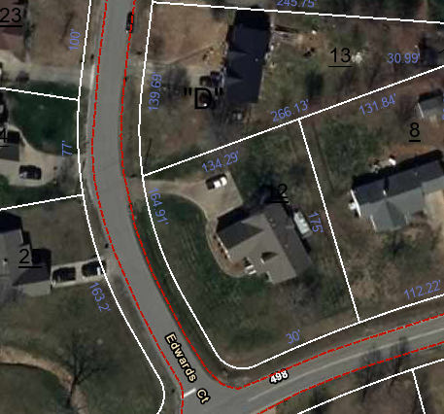100 Edwards Court

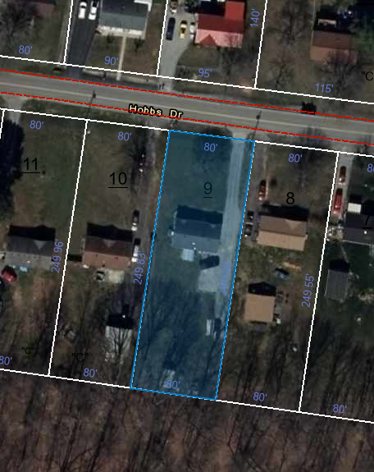209 Hobbs Dr